AI LAB ASSIGNMENT 6.4:

NAME:M.VARSHITHA

HALLTICKET NO:2403A52342

TASK 1:write a python class named student with attributes name,roll_number,and marks using functions and take user input and it should generate methods like display_details and is_passed and use if-else conditions .

CODE:

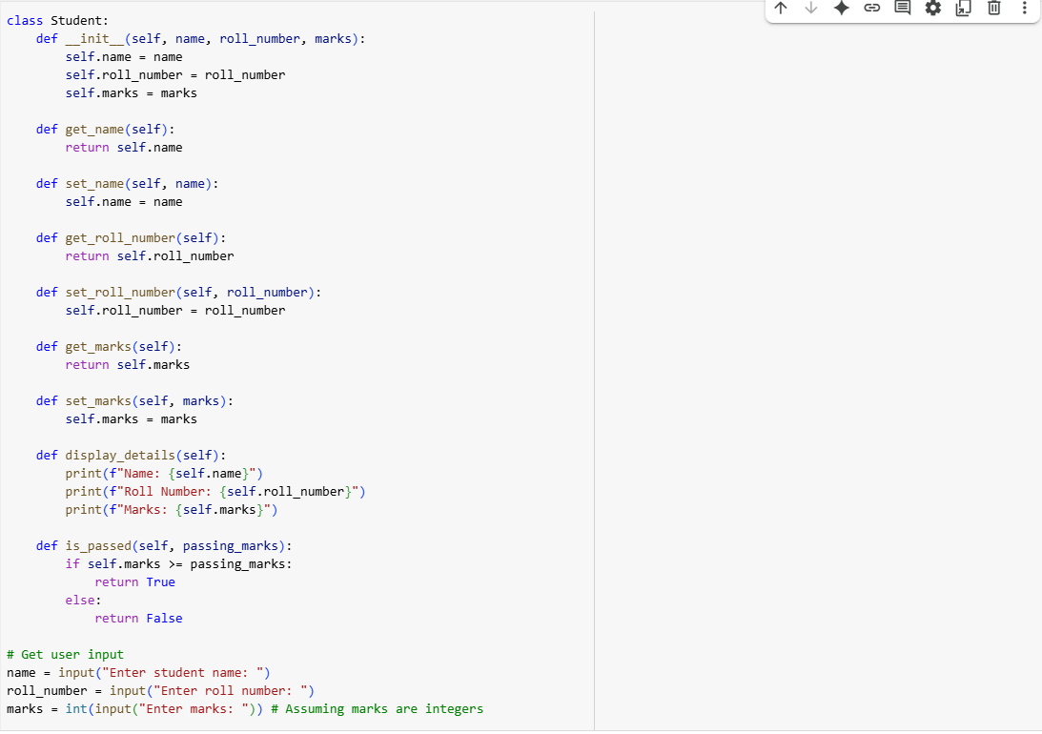

OUTPUT:

EXPLANATION:

TASK 2:

numbers=[1,2,3,4,5] for i in numbers: write a python program to calculate and print the square of even numbers only.

CODE:

OUTPUT:

EXPLANATION:

TASK 3:write a python program to create a class called bankaccount with attributes account_holder and balance using deposit(), withdraw(), and check for insufficient balance and also Code should prevent overdrawing.

CODE:

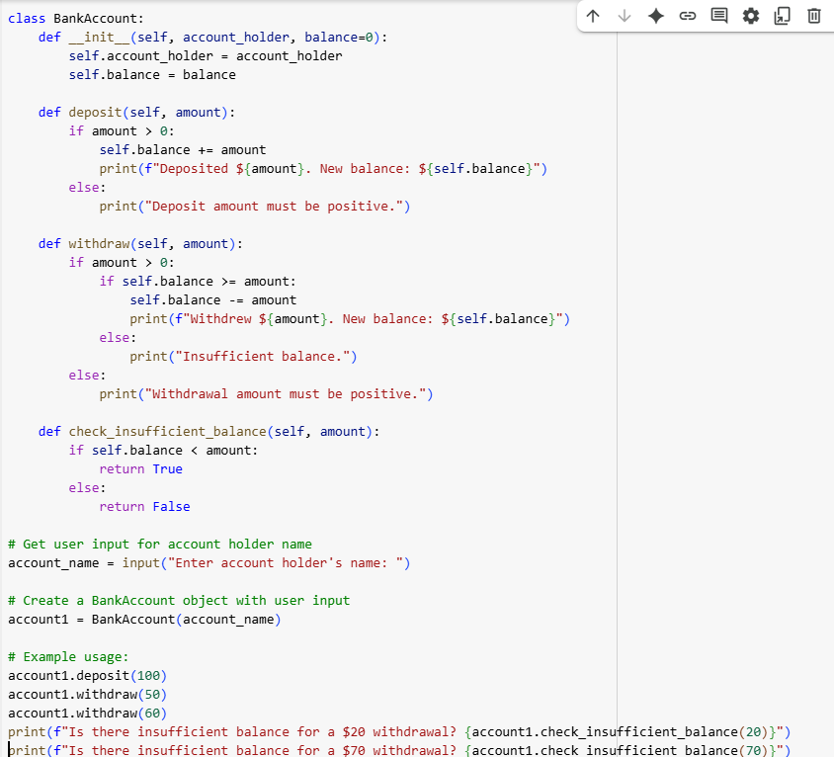

OUTPUT:

EXPLANATION:

TASK 4: students = [ {"name": "Alice", "score": 85}, {"name": "Bob", "score": 75}, {"name": "Charlie", "score": 74}, {"name": "David", "score": 98}, {"name": "Eve", "score": 36} ] write a while loop to print names of students who scored more than 75

CODE:

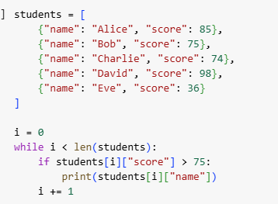

OUTPUT:

EXPLANATION:

TASK 5:write a class shoppingcart with empty items list and use methods add_item,remove_item,and use a loop to calculate the total bill using conditional discounts

CODE:

OUTPUT:

EXPLANATION:

